Weekly Status Report
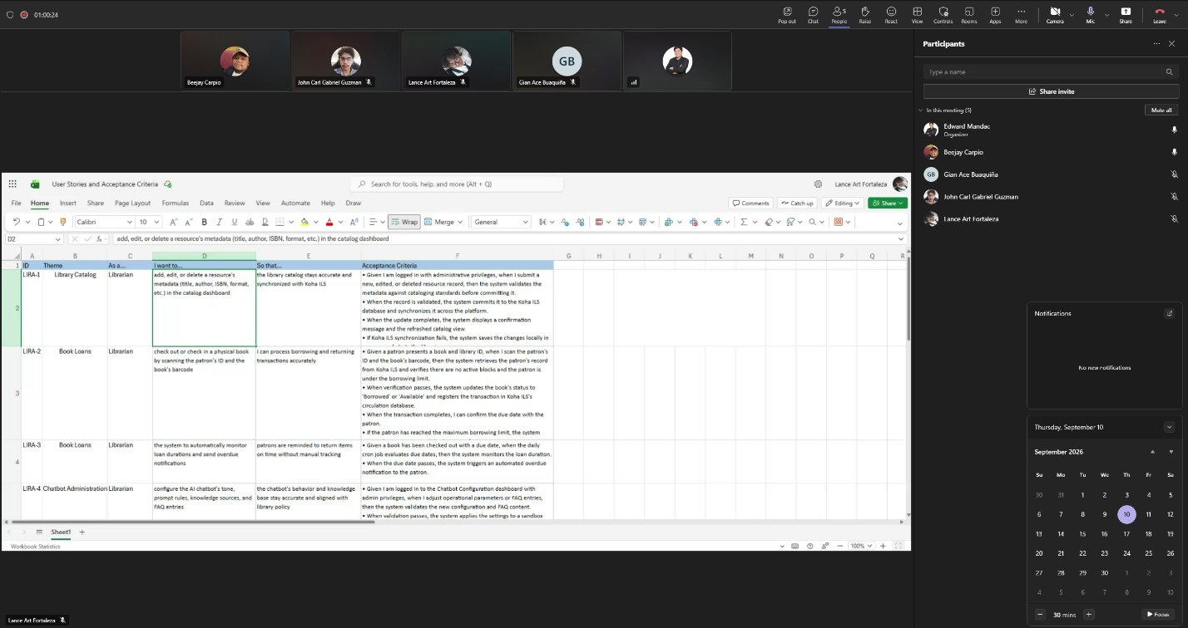
Minutes of Meeting Date: 09-10-2026
Meeting Called By: Cache Flow
Facilitator: Edward Mandac
Link of the Meeting: Cache Flow - Weekly Status Meeting-20260910_184238-Meeting Recording.mp4

Attendees:
Gian Ace Buaquiña
Beejay A. Carpio
Lance Art P. Fortaleza
John Carl Gabriel B. Guzman

Agenda:
- What are the deliverables and topics for this Sprint
- Establish project roadmap and prioritize web portal foundation before AI chatbot integration
- Learn user story and story point
- Establish rules for handling dependencies, blockers, concurrent tasks, and team capacity

Summary
- We discussed the development roadmap, sprint planning methodologies, and technical dependencies for the Koha integration project.
- We established sprint guidelines for handling tasks, team capacity, and immediately flagging blockers to resolve dependencies.

Blockers / Obstacles encountered this week
- Database & Client Data Access: The team needs to meet with the client/librarian (Mrs. April) and ITRO tomorrow to confirm if Koha database access or a sample database will be provided. Source Code Access: Pending alignment with ITRO regarding access to the current library website source code and system permissions.

